**Arduino Pressure and Spirometer With/Without Valve Control**

**Addressed Concerns from Cornell Redesign Research Doc:** *Improve upon the crude nature of the Cornell Design (manual pressure gauges/spirometers) - is there a way to make this more seamlessly integrated? Some sort of software to plug into a ventilator that seamlessly provides specific pressure/volume to different tubes? We may even be able to add a spirometer to assist with tidal volume measurements, and some sort of alert system if any of these things are changed so doctors don’t have to constantly be monitoring this*

*The CO2 monitor can be used to also alert doctors for hypercapnia or hypocapnia (pH of blood/gas)*

**Without Valve Control:** The standard Cornell design uses analog pressure gauges and spirometers. This idea aims to digitize all the sensors, display the data on a screen, and alert the medical professional if any of the parameters go out of bounds. This will massively cut down on the time needed for the medical professional to operate the ventilator as all the information is displayed centrally on a screen, and the medical professional would not have to constantly check on the pressure gauges with the alert system. This system would also enable adding CO2/O2 sensors as well, if needed. The pressure valve controller would be a manual one, where the operator would turn it to adjust the pressure.

Pressure Sensor (I am not completely sure if this will work for the pressures needed in a ventilator. Measures up to 8.75 kPa above atm): <https://www.adafruit.com/product/1603>

<https://learn.sparkfun.com/tutorials/bmp180-barometric-pressure-sensor-hookup-/all>

Spirometer: <https://www.instructables.com/id/Spirometer/>

<https://www.instructables.com/id/Low-Cost-Spirometer/>

**With Valve Control:** This would involve a negative feedback loop between the pressure sensors and the valve controller. This is more complex as we would need to build an electronic pressure valve controller. However, this would eliminate the need for anyone to keep manually adjusting the pressure valve, as this would be done by the Arduino electronically. The pressure valve would most likely be a solenoid valve.

Valve Control Ideas: <https://www.instructables.com/id/Pressure-Control-Using-Arduino/>

<https://www.bc-robotics.com/tutorials/controlling-a-solenoid-valve-with-arduino/>

<https://www.instructables.com/id/Controling-a-solenoid-valve-with-an-Arduino/>

Rough sketch on next page->

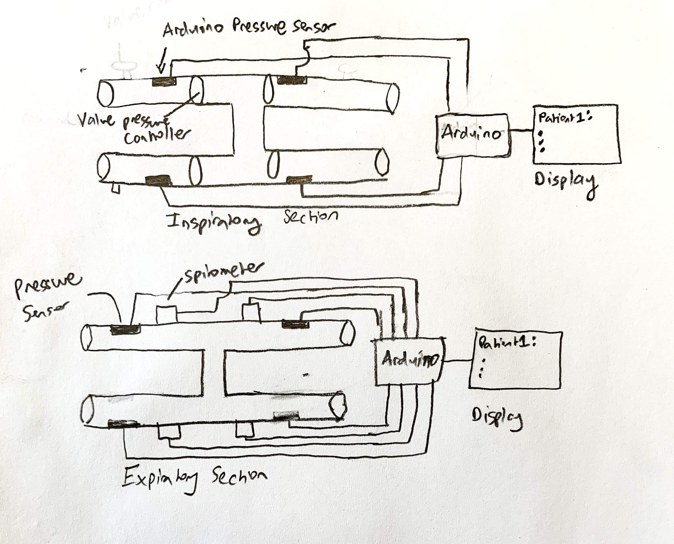*Assumes the “H” design for now.